CS 1111 – Assignment Activity Unit 3:
Boolean Algebra and Logic Gates in an Access Control System

Task 1: Simplifying (I · A) + (L′ · A)
The first thing I noticed when I looked at this expression is that both terms end in A. I·A has an A, and L′·A has an A too. That's usually a sign that factoring is possible, kind of like in normal algebra, where xy + xz turns into x(y+z).
Step one, I just reordered the second term using the Commutative Law (order doesn't matter in AND/OR operations), so L′·A becomes A·L′. That gives:
(A·I) + (A·L′)
Step two, the Distributive Law lets A be pulled out front, since it's common to both terms:
A·(I + L′)
And that's it — there's nothing left to cancel or absorb, because I and L′ aren't complements of each other. So the simplified expression is:
A · (I + L′)
What this means for the actual door: the lab only unlocks if the admin override is on, and on top of that, either the ID was scanned or the lab happens to be free. Functionally, it's identical to the original, just built with one less AND operation, which reduces the number of gates needed in the circuit and makes the logic design a bit simpler overall (Ndjountche, 2016).

Task 2: De Morgan's Theorem on L′·A
De Morgan's Theorem basically says that when you complement an AND expression, it turns into an OR of the complemented pieces (and the reverse works too for OR). Written out:
(X·Y)′ = X′ + Y′
Applying that to L′·A:
(L′·A)′ = (L′)′ + A′
Since double-complementing a variable just gives the variable back (this is the Involution Law), (L′)′ becomes L, so:
(L′·A)′ = L + A′
So instead of “lab free AND override active,” the complement reads as “lab in use OR override not active.” Every AND flips to an OR and every variable gets complemented — that's the whole trick.
What I think is worth pointing out is that De Morgan's isn't really separate from the other laws; it kind of grows out of them. The Distributive Law lets you switch between an expanded and a factored form of the same logic, and De Morgan's does something similar, except it switches between AND-style and OR-style versions of the same logic. That connection is why NAND and NOR gates are called “universal” — De Morgan's guarantees that any Boolean expression can be rewritten using only NAND gates or only NOR gates, since AND, OR, and NOT can all be built from either one (Westcott & Westcott, 2023). For a lab access system, that matters because a design that only needs one type of gate is usually easier and more efficient to implement than one mixing several gate types (Neso Academy, 2021).
Task 3: Diagram and Truth Table for A · (I + L′)
Three gates are needed here: a NOT gate for L, an OR gate for I and L′, and a final AND gate combining that OR output with A.
Logic Gate Diagram:
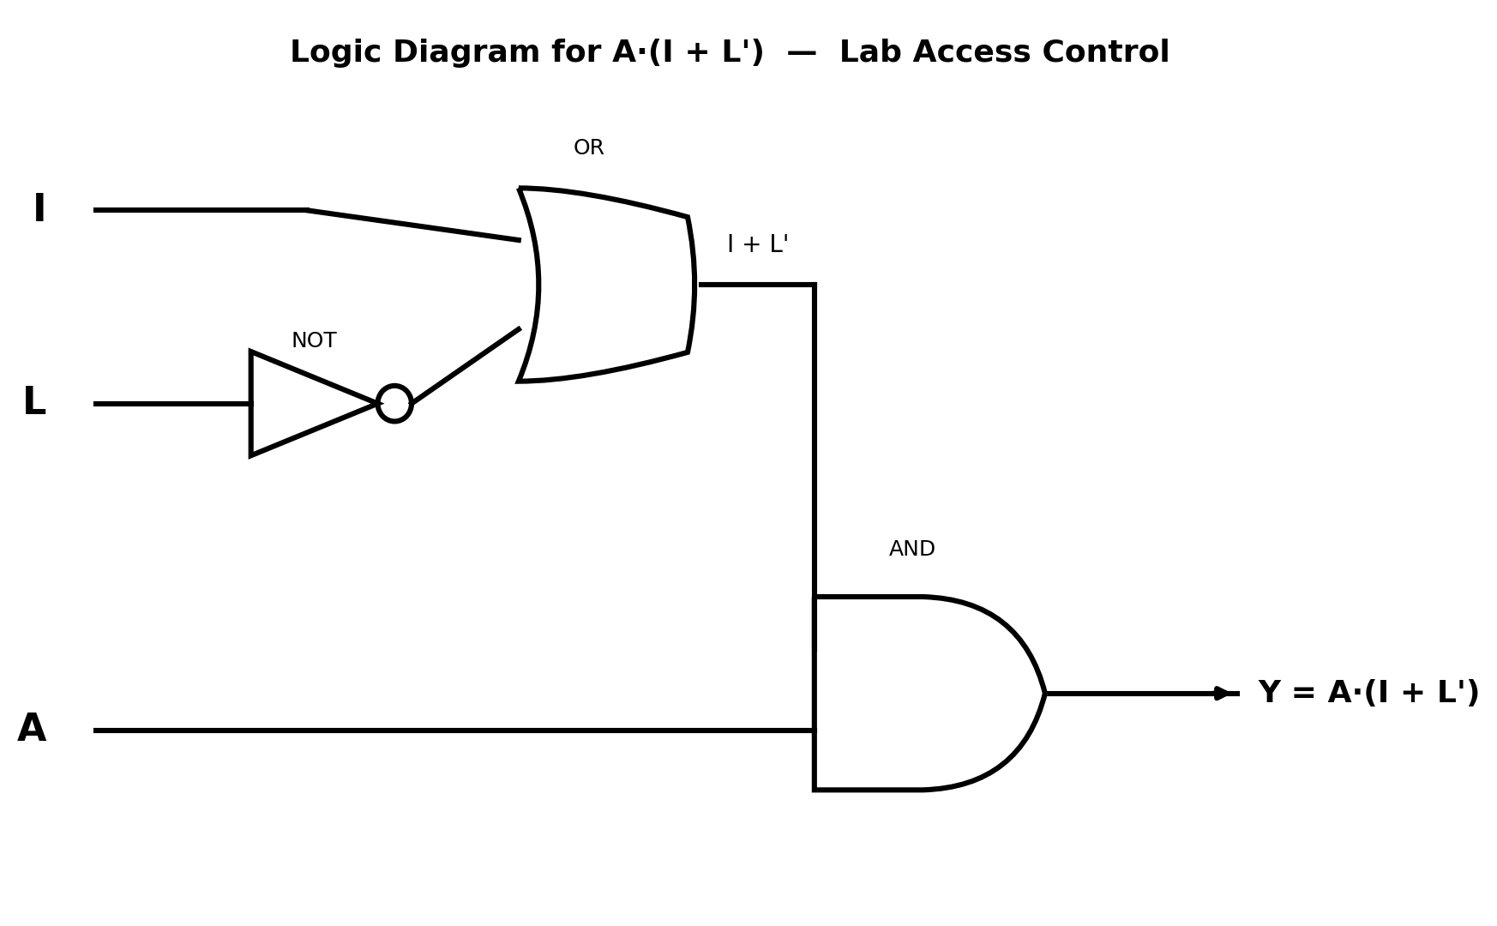
Truth Table – Simplified Expression A·(I + L′):
A | I | L | L′ | I + L′ | Y = A·(I+L′)
0 | 0 | 0 | 1 | 1 | 0
0 | 0 | 1 | 0 | 0 | 0
0 | 1 | 0 | 1 | 1 | 0
0 | 1 | 1 | 0 | 1 | 0
1 | 0 | 0 | 1 | 1 | 1
1 | 0 | 1 | 0 | 0 | 0
1 | 1 | 0 | 1 | 1 | 1
1 | 1 | 1 | 0 | 1 | 1

Task 4: Checking the Two Expressions Match
Truth Table – Original Expression (I·A) + (L′·A):
A | I | L | I·A | L′ | L′·A | Output
0 | 0 | 0 | 0 | 1 | 0 | 0
0 | 0 | 1 | 0 | 0 | 0 | 0
0 | 1 | 0 | 0 | 1 | 0 | 0
0 | 1 | 1 | 0 | 0 | 0 | 0
1 | 0 | 0 | 0 | 1 | 1 | 1
1 | 0 | 1 | 0 | 0 | 0 | 0
1 | 1 | 0 | 1 | 1 | 1 | 1
1 | 1 | 1 | 1 | 0 | 0 | 1

Comparing the Output column above (0, 0, 0, 0, 1, 0, 1, 1) with the Y column from Task 3 (0, 0, 0, 0, 1, 0, 1, 1), row by row, they match exactly. So even though A·(I+L′) looks like less “work” on paper, it unlocks the door under the exact same conditions as the longer version. That's really the whole point of simplifying — same behavior, fewer components.
References
Ndjountche, T. (2016). Digital electronics 1: Combinational logic circuits. Wiley. https://doi.org/10.1002/9781119318620
Westcott, S., & Westcott, J. R. (2023). Basic electronics: Theory and practice (4th ed.). Mercury Learning & Information. https://doi.org/10.1515/9781683929574
Neso Academy. (2021, September 15). De Morgan's law in Boolean algebra explained [Video]. YouTube. https://www.youtube.com/watch?v=WW-NPtIzHwk

